This case study investigates the role of the Olympic Federation in the transformational and authentic leadership of young people.

The Olympic Federation stands firm in its guiding principles of the Olympic Charter: 'The practice of sport is a human right'. Everyone should be able to play sport 'without discrimination of any kind and in the Olympic spirit, which requires mutual understanding with a spirit of friendship, solidarity and fair play.' (Pierre de Coubertin, Founder of the Modern Olympic Games).

De Coubertin was an educationalist, and believed that sport could contribute to the development of a better world, promote fair play, and serve as a means to educate and build the character of those that participated in it.

We can readily call on a wide range of beneficial humanitarian and education projects developed by the Federation for examples of how the organisation stands firm in its values; for example, via partnerships with the United Nations, rehabilitative programmes in war-torn regions, and a multitude of educational programmes.


Image created by Marc Lacoste and reproduced under a Creative Commons licence.
We can further observe the heroic, positive acts of athletes that set the foundations for a thousand dreams in the hearts and minds of a young audience. The sporting records, performances and achievements of the fastest and strongest athletes in the world inspire our youth of today and tomorrow to become athletes, to excel in every area of their life, and to make positive choices.

Olympism therefore offers a powerful platform to motivate and inspire young people to be the best that they can be; to make healthy choices and to perform beyond expectations. Such a concept shares striking similarities with the most dominant paradigm in modern-day leadership studies; transformational leadership.

Transformational Leadership
Bass and Avolio (1994) state that transformational leadership occurs when leaders no semi-colon stimulate others to see new perspectives; articulate the vision of the organisation; develop others to higher levels of ability; and motivate others to put organisational interests before self interests. A strong morality must also be possessed by the transformational leader. The demonstration of transformational behaviours and morality in a leader is statistically correlated with superior levels of performance across a range of industries (business, education, religion, sport) and continents. The existence of morality as a defining factor for success has strongly affected the development of the newest and most dominant paradigm in current leadership theory, authentic leadership that requires authenticity, honesty and integrity from the leader for successful leadership outcomes to occur.

Authentic Leadership
Proponents of Authentic Leadership argue for higher standards of leadership behaviour and call for greater congruence between a leaders’ message and their actual actions. In Australia, Bhindi and Duignan (1997) called for greater authenticity in leadership to counterbalance toxic influences such as rampant corporate managerialism and the increasing dehumanizing, political expediency, subterfuge and hypocrisy people experience in their workplaces and private lives (see also Duignan and Bhindi, 1997). The authors place a central focus of ethical behaviour and spirituality.


Image created by dalli58 and reproduced under a Creative Commons licence.

Authenticity Issues
When one observes the Olympic Charter, and the many Olympic initiatives promoting peace and solidarity, one might conclude that the Olympic Federation offers an interesting and valuable example of transformational and authentic leadership. After all, the organisation works alongside the United Nations, provides developmental opportunities and funding to third world countries, and inspires youngsters all over the world to choose a healthier way of living, to chase their dreams, to play fair and to be the best they can be.
However, some people have questioned the authenticity of the Olympic Federation in terms of its demonstrated coherence between the Olympic Spirit and its actions. A brief sprint through the 1900’s shows us why such questioning might have emerged. One might consider, for example, the way in which the Olympic Federation expelled Gold-medal winning US athletes Tommy Smith and John Carlos from the Olympic Villages, following their now iconic Black Power Salute (Mexico, 1968).

Another famous example was the decision taken by the Olympic Federation to award the Games to Nazi Germany, a move that assisted the legitimisation of Hitler’s Third Reich. Evidence of human rights abuses directed at Jews existed at the time, but was ignored by the Federation, and Hitler was to go on to successfully utilise the Olympic Games as propaganda tool, largely via the commissioning of the Leni Riefenstahl docu-film Olympia.

Use of Riefenstahl Footage in the Vancouver 2010 Games
This example actually re-emerged during the recent Vancouver 2010 Games. The Olympic Federation took the decision to use 22 seconds of footage from the Reni Liefenstahl film Olympia as the opener for a major Vancouver 2010 Winter Olympics promotional video. Use of this 22 seconds required the editing out of Swastika’s in order to include it in the Vancouver 2010 video in an acceptable way. Such a decision has caused some parts of society to question the authenticity of the Olympic Federation in terms of conforming to its own principles (that sport should be practised without discrimination).

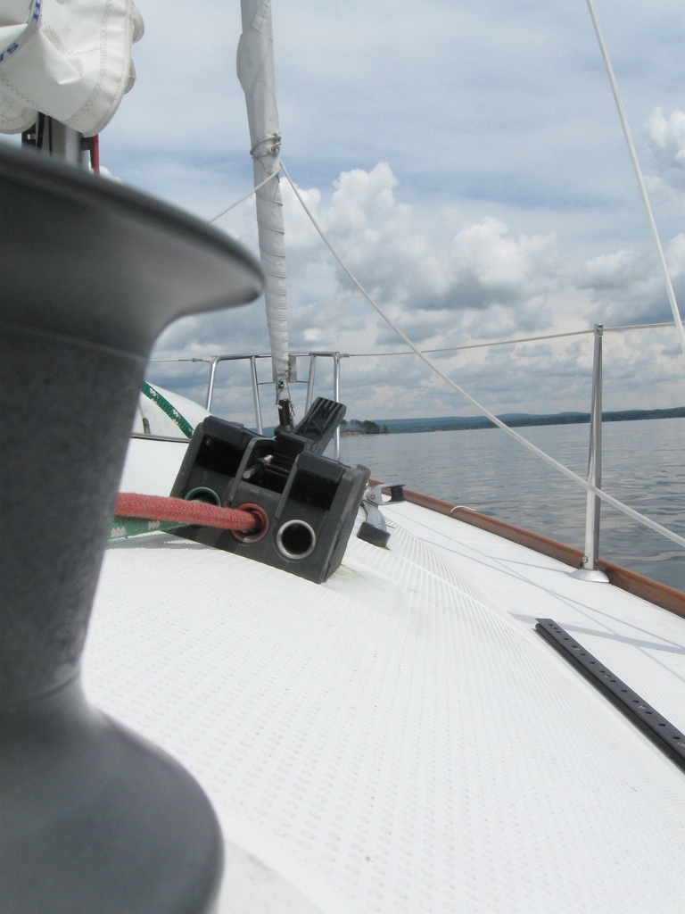
Image created by Kate Tomlinson and reproduced under a Creative Commons licence.

Authenticity and Big Business
It should be remembered that the Olympic Federation is a corporation, one that has developed an extremely successful and powerful brand. This brand is built on a powerful image that expounds the virtues of the Olympic spirit, that carries notable political clout and that seeks brand loyalty, profit generation and market share above all else. One must not lose sight of this fact when considering the authenticity of any organisation; that it operates under the auspices of capitalism and that its bottom line, above all else, is the generation of income. This is not necessarily a bad thing!- but it does raise an interesting question as to whether Corporate Social Responsibility initiatives are in general really authentic, or simply used as a tool to promote the brand (a concept as applicable to any organisation as it is to the Olympic Federation).

Summary
Is the concept of the Olympic spirit simply a brilliant marketing tool used to sustain market share and build profit, or does the organisation actually believe in these principles? If the former is taken to be true, then we should fairly expect to see significant levels of authenticity demonstrated by the Federation. Some people believe this to be very much the case; others do not.

The case for authenticity:
The Olympic Federation have inspired young people across the world to choose sport; athletes have provided us with incredible role models, and numerous educational and social initiatives have allowed the Olympic Federation to help individuals across the world to lead a better life. Work with the United Nations provides a testament to this, and the concept of the Olympic Truce is a lovely example of the promotion of peace. When viewing these concepts one could easily argue for authentic leadership within the Olympic Federation.

The case against authenticity:
It is possible to argue that the Olympic Federation lacks authenticity, based on the many instances of corruption and questionable human rights-related decisions that the Federation has been responsible for. According to some (e.g. those demonstrating against the awarding of the Games to China), it is possible to argue that the founding principles and modus operandi of the Olympic Federation appear to lack coherence, and that the only positive messages to really arise from the Games are generated by the athletes (something that the athletes achieve in any competition that they compete in). A potential concern might be that some young people become disenfranchised from the inspiring message of the Olympic spirit, based on their knowledge of the student protests before the Mexico Games (when many lost their lives), the treatment of Tommie Smith and John Carlos after their Black Power Salute, the treatment of the Black September situation at the Munich Games, the controversies of the torch relay of the Beijing Games, the awarding of the Games to Hitler’s Germany or the use of the Riefenstahl film to promote the Vancouver Games.

START THE DISCUSSION
- What is transformational leadership?
- What is authentic leadership?
- Why are morals and ethics viewed as being so central to both leadership models?
- Some detractors believe that the Olympic Federation helped legitimise Hitler’s Third Reich by awarding the 1936 Games to Germany. Do you think that this criticism is fair, or that sport and politics really do not, and should not, mix?
- How do you feel about the use of Riefenstahl footage in the Vancouver promotional materials?
- Higher morals = maximised profit is not a message we are used to hearing. Why do you think this is the case?
- Do you feel that the Olympic Federation is an authentic organisation?
- Debate: Form two teams and debate the following motion: This house believes that the Olympic Federation is an authentic organisation.
- Do you think it is the athletes, the Federation, or both, that are responsible for creating the inspirational messages that are generated by the Games?

FIND OUT MORE

Milton-Smith, J. (2002). Ethics, the Olympics and the Search for Global Values. Journal of Business Ethics, Vol. 35, No 2. Springer Netherlands.
http://www.springerlink.com/content/m14966u540006774/

Economy, E.C., Segal, A. (2008) China’s Olympic Nightmare: What the Games Mean for Beijing’s Future. 87; 4. Foreign Affairs.

Eisen, G. (1984). The Voices of Sanity: American Diplomatic Reports from the 1936 Berlin Olympiad. Journal of Sport History. Vol 11, No 3.
http://www.s-port.de/david/bibliothek/jsh1103d.pdf

CREDITS
© Oxford Brookes University 2010. oxb:060111:37dd

This resource was produced as part of the 2012 Learning Legacies Project managed by the HEA Hospitality, Leisure, Sport and Tourism Subject Centre at Oxford Brookes University and was released as an Open Educational Resource. The project was funded by HEFCE and part of the JISC/HE Academy UKOER programme. Except where otherwise noted above and below, this work is released under a Creative Commons Attribution only licence.

Exceptions to the Licence
The name of Oxford Brookes University and the Oxford Brookes University logo are the name and registered marks of Oxford Brookes University. To the fullest extent permitted by law Oxford Brookes University reserves all its rights in its name and marks, which may not be used except with its written permission.

The JISC logo is licensed under the terms of the Creative Commons Attribution-Non-Commercial-No Derivative Works 2.0 UK: England & Wales Licence. All reproductions must comply with the terms of that licence.

The Higher Education Academy logo and the HEA Hospitality, Leisure, Sport and Tourism Subject Centre logo are owned by the Higher Education Academy Limited and may be freely distributed and copied for educational purposes only, provided that appropriate acknowledgement is given to the Higher Education Academy as the copyright holder and original publisher.



Reusing this work
To refer to or reuse parts of this work please include the copyright notice above including the serial number. The only exception is if you intend to only reuse a part of the work with its own specific copyright notice, in which case cite that.

If you create a new piece of work based on the original (at least in part), it will help other users to find your work if you modify and reuse this serial number. When you reuse this work, edit the serial number by choosing 3 letters to start (your initials or institutional code are good examples), change the date section (between the colons) to your creation date in ddmmyy format and retain the last 5 digits from the original serial number. Make the new serial number your copyright declaration or add it to an existing one, e.g. ‘abc:101011:037dd’.

If you create a new piece of work or do not wish to link a new work with any existing materials contained within, a new code should be created. Choose your own 3-letter code, add the creation date and search as below on Google with a plus sign at the start, e.g. ‘+tom:030504’. If nothing comes back citing this code then add a new 5-letter code of your choice to the end, e.g.; ‘:01lex’, and do a final search for the whole code. If the search returns a positive result, make up a new 5-letter code and try again. Add the new code your copyright declaration or add it to an existing one.

